FINANCIAL
STATEMENT
ANALYSIS
-Shaurya Sharma
(BBA Analytics)

Table Of Content
1) Declaration--------3
2) Research Methodology-------4
3) Company Profile-----------5
4) Profit & Loss Statement----------7
5) Cash Flow Statement---------8
6) Ratio Analysis--------------9
7)Conclusion------------10
8)Dashboard Visualization-------------12
9)Charts---------------13
10)Bibliography----------------14

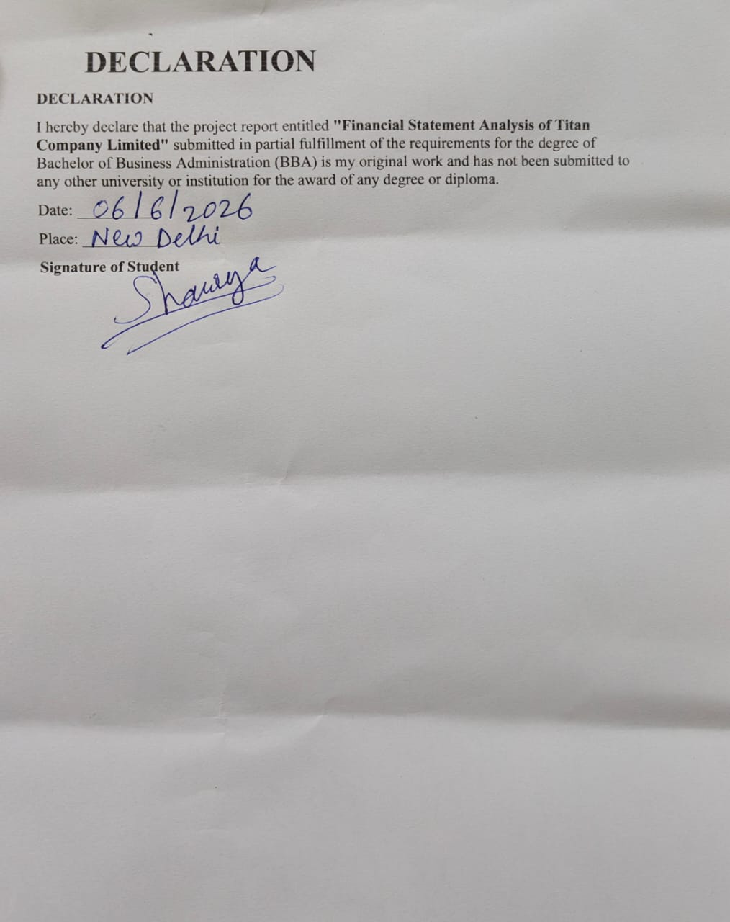

RESEARCH METHODOLOGY

Introduction
Research Methodology refers to the systematic process adopted for collecting, analyzing, and interpreting financial data for the purpose of the study.

Nature of Study
The present study is descriptive and analytical in nature. It focuses on evaluating the financial performance of Titan Company Limited using financial statements and ratio analysis techniques.

Sources of Data
The study is based entirely on secondary data.

SECONDARY DATA SOURCE
- Annual Reports of Titan Company Limited
- Company's published financial statements
- Official company website
- Stock exchange disclosures
- Financial databases and reports

Period of Study
The study covers a period of five financial years from 2021 to 2025.

Tools and Techniques Used
The following tools and techniques have been used for analysis:

FINANCIAL STATEMENT ANALYSIS
- Balance Sheet Analysis
- Profit & Loss Statement Analysis
- Cash Flow Statement Analysis

RATIO ANALYSIS
- Current Ratio
- Debt-to-Equity Ratio
- Net Profit Margin
- Return on Equity (ROE)
- Asset Turnover Ratio

DATA VISUALIZATION
- Trend Charts
- Comparative Analysis
- Dashboard Representation using Microsoft Excel

Limitations of the Study
- The study is based only on secondary data collected from published sources.
- The analysis is limited to the financial information available in annual reports.
- The study covers only a five-year period.
- External factors such as economic conditions, government policies, and market competition are not analyzed in detail.
- Findings are based on historical financial data and may not reflect future performance

COMPANY PROFILE

Titan Company Limited
Titan Company Limited is one of India's leading lifestyle companies and a part of the Tata Group. The company was established in 1984 as a joint venture between the Tata Group and the Tamil Nadu Industrial Development Corporation (TIDCO).
Titan initially started its operations in the watch segment and later diversified into jewellery, eyewear, perfumes, fashion accessories, and wearable products. The company is best known for its jewellery brand Tanishq, which has become one of the most trusted jewellery brands in India.
Over the years, Titan has established a strong retail presence across the country through its various brands and exclusive outlets. The company focuses on innovation, quality, customer satisfaction, and sustainable business practices.
Titan Company Limited is listed on the National Stock Exchange (NSE) and Bombay Stock Exchange (BSE) and is considered one of the leading companies in India's consumer lifestyle sector.

Key Information
- Company Name: Titan Company Limited
- Industry: Consumer Lifestyle Products
- Founded: 1984
- Headquarters: Bengaluru, Karnataka, India
- Parent Group: Tata Group
- Major Brands: Tanishq, Fastrack, Titan, Sonata, Titan Eye+
- Stock Exchange Listing: NSE & BSE

BALANCE SHEET
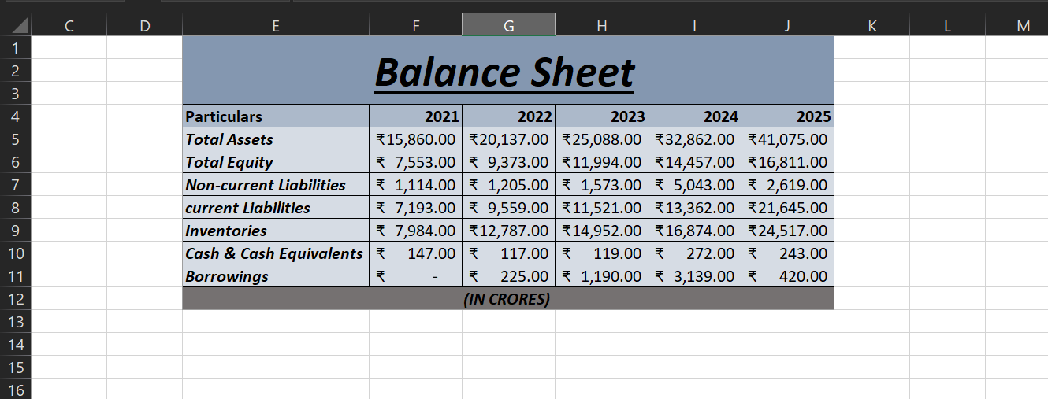

Asset Analysis
- The total Assets increased from ₹15,860 crore in 2021 to ₹41,075 crore in 2025.
- This growth reflects significant expansion in the company's resource base.

Equity Analysis
- Shareholders' Equity increased from ₹7,553 crore to ₹16,811 crore.
- The increase indicates growth in retained earnings and shareholder wealth which is a positive sign.

Liability Analysis
- Current Liabilities increased from ₹7,193 crore to ₹21,645 crore.
- Non-current Liabilities increased overall but fluctuated during the period.
- The increase in liabilities supports business expansion and working capital requirements which peaked between 2024-25 ,i.e: 61.9% increase from 2024.

Inventory Analysis
- Inventory rose from ₹7,984 crore to ₹24,517 crore.
- The growth in inventory is consistent with increasing sales volume and operational scale.

Cash Position
- Cash and Cash Equivalents remained relatively stable.
- The company maintained adequate liquidity despite expansion activities.

Borrowings
- Borrowings increased until 2024 and then reduced significantly in 2025.
- This indicates efforts by the company to reduce debt obligations and improve financial stability.

Interpretation
The Balance Sheet reflects a growing company with increasing assets, equity, and operational scale. The reduction in borrowings during 2025 further strengthens the financial position of the company.
PROFIT & LOSS STATEMENT
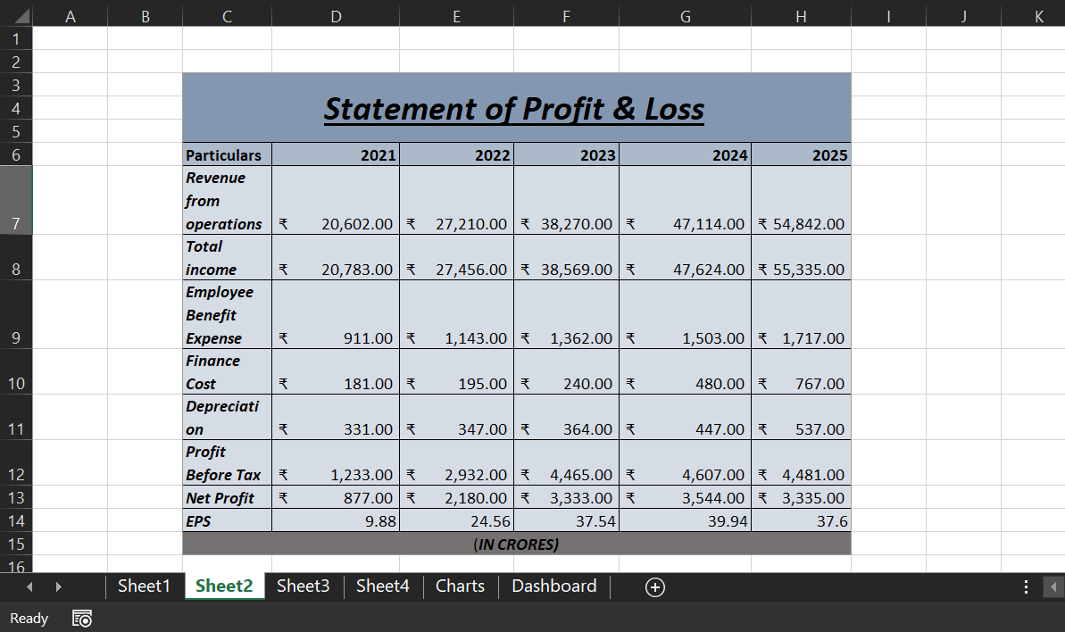

Revenue Analysis
- Revenue from Operations increased from ₹20,602 crore in 2021 to ₹54,842 crore in 2025.
- This represents significant growth over the five-year period.
- The steady rise in revenue indicates increasing customer demand and expansion of business operations.
- The highest revenue was recorded in 2025.
- A huge 23.10% growth was scene from 2023 to 2024. It marked the highest percentage of revenue generated between two years from 2021-2025.

Profitability Analysis
- Net Profit increased from ₹877 crore in 2021 to ₹3,335 crore in 2025.
- Profit grew substantially between 2021 and 2024, indicating efficient business performance.
- Although profit slightly declined in 2025 compared to 2024, it remained significantly higher than earlier years.

Cost Analysis
- Employee Benefit Expenses increased from ₹911 crore to ₹1,717 crore.
- Finance Costs rose from ₹181 crore to ₹767 crore, indicating higher borrowing costs.
- Depreciation expenses increased gradually, reflecting investment in fixed assets and business expansion.

Earnings Per Share (EPS)
- EPS increased from 9.88 in 2021 to 37.60 in 2025.
- The improvement in EPS indicates better returns available to shareholders.

Interpretation
Overall, the Profit & Loss Statement shows strong growth in revenue and profitability. The company has successfully expanded its operations while maintaining healthy earnings over the five-year period.
CASH FLOW STATEMENT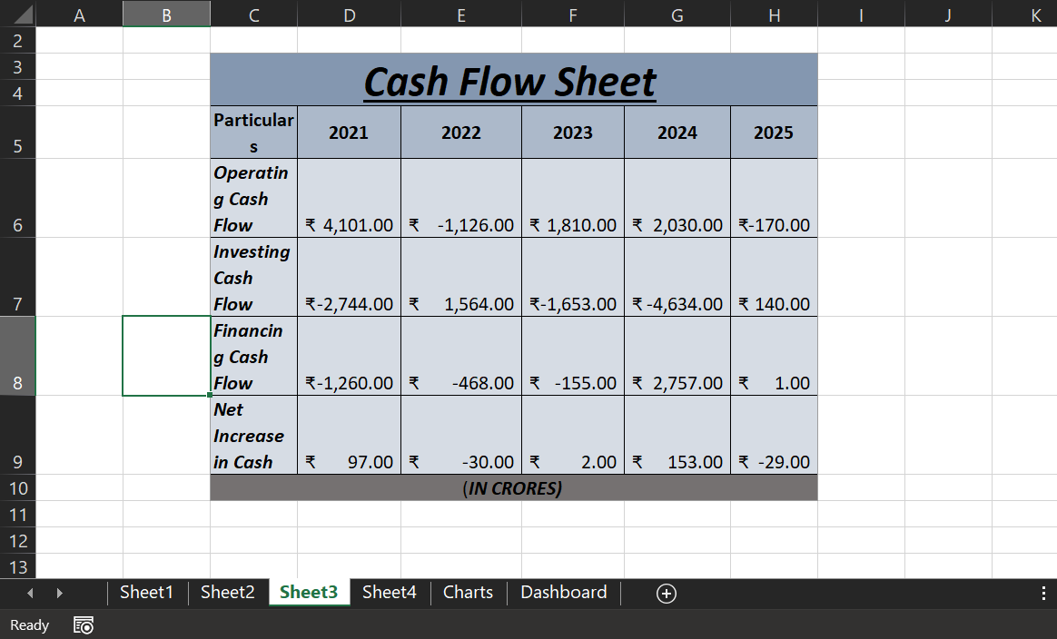

Operating Cash Flow
- Operating Cash Flow remained positive in most years.
- Positive operating cash flow indicates the company's ability to generate cash from core business activities.
- A slight negative operating cash flow in 2025 may be due to increased working capital requirements.

Investing Cash Flow
- Investing Cash Flow remained negative in most years.
- Negative investing cash flow generally indicates investment in assets, expansion projects, and long-term growth opportunities.
- Positive investing cash flow in 2025 suggests lower capital expenditure or asset disposal during the year.

Financing Cash Flow
- Financing Cash Flow was mostly negative, indicating repayment of debt and distribution to shareholders.
- Positive financing cash flow in 2024 reflects additional funding raised during the year.

Net Increase in Cash
- Net increase in cash fluctuated throughout the period.
- Despite fluctuations, the company maintained a stable cash position.

Interpretation
The Cash Flow Statement indicates that the company is actively investing in future growth while maintaining reasonable liquidity. Cash flow patterns are generally consistent with a growing business.
FINANCIAL RATIOS
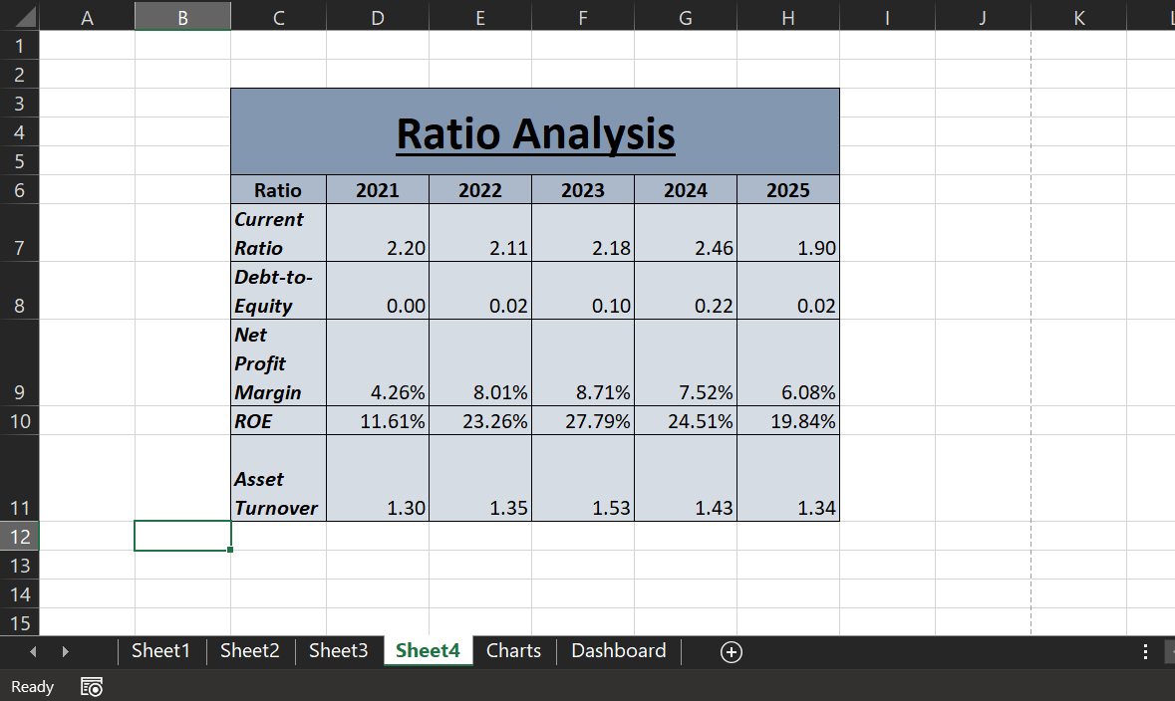

Current Ratio
- Current Ratio remained above 1 throughout the period.
- It ranged between 1.90 and 2.46.
- This indicates that the company maintained adequate short-term liquidity.

Debt-to-Equity Ratio
- Debt-to-Equity Ratio remained very low.
- The highest ratio was only 0.22 in 2024.
- Low leverage indicates a conservative financing structure and lower financial risk.

Net Profit Margin
- Net Profit Margin improved from 4.26% in 2021 to 6.08% in 2025.
- The margin peaked at 8.71% in 2023.
- This indicates efficient cost management and profitability.

Return on Equity (ROE)
- ROE increased from 11.61% to 19.84%.
- ROE reached a peak of 27.79% in 2023.
- Higher ROE indicates efficient utilization of shareholders' funds.

Asset Turnover Ratio
- Asset Turnover Ratio remained above 1 throughout the period.
- The ratio peaked at 1.53 in 2023.
- This indicates efficient utilization of assets to generate revenue.

Interpretation
The ratio analysis demonstrates strong liquidity, low financial risk, healthy profitability, and efficient utilization of assets and shareholder funds.

OVERALL CONCLUSION
The financial analysis of Titan Company Limited for the period 2021–2025 indicates strong business growth and financial performance. Revenue from operations and net profit increased substantially over the five-year period, reflecting successful expansion and strong market demand. The balance sheet shows significant growth in assets and shareholders' equity, while maintaining a relatively low debt position.
The cash flow analysis suggests that the company has consistently invested in business expansion while maintaining adequate liquidity. Ratio analysis further confirms the company's strong financial health through healthy profitability, efficient asset utilization, satisfactory liquidity, and low financial risk.
Overall, Titan Company Limited demonstrates strong financial stability, sustainable growth, and effective management of resources, making it a financially sound and well-performing company during the study period.

DASHBOARD
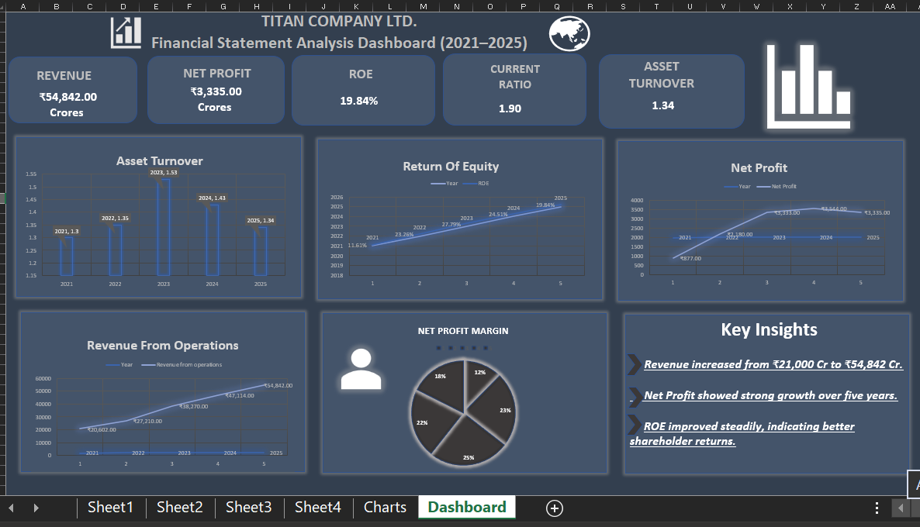
CHARTS:
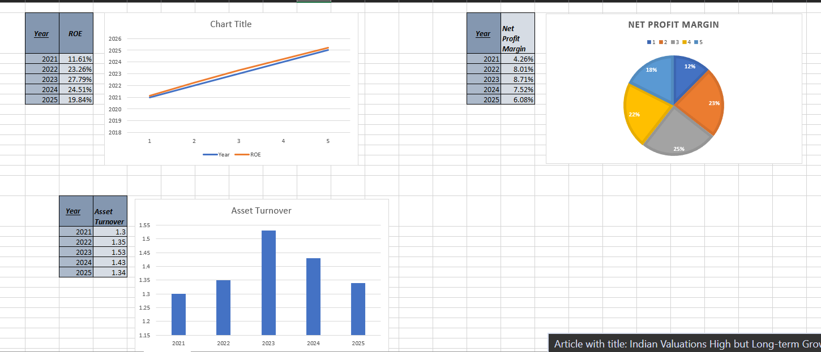
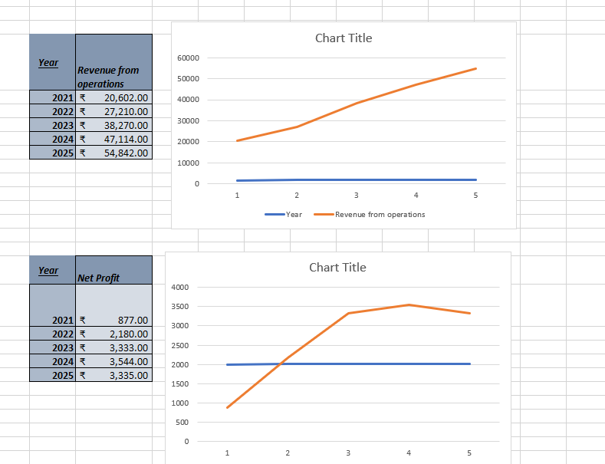chart-2
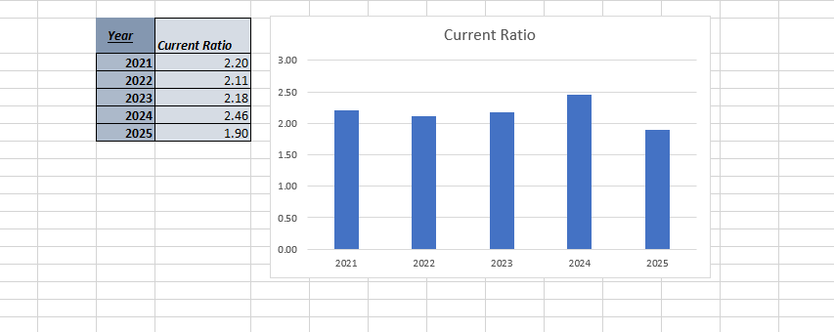
CHART-3

BIBLIOGRAPHY

Books
- Pandey, I. M. Financial Management. Vikas Publishing House, New Delhi.
- Khan, M. Y., and Jain, P. K. Financial Management: Text, Problems and Cases. McGraw Hill Education.
- Maheshwari, S. N., and Maheshwari, S. K. Financial Statement Analysis and Reporting. Vikas Publishing House.

Annual Reports
- Titan Company Limited. Annual Report 2020-21.
- Titan Company Limited. Annual Report 2021-22.
- Titan Company Limited. Annual Report 2022-23.
- Titan Company Limited. Annual Report 2023-24.
- Titan Company Limited. Annual Report 2024-25.

Websites
- Titan Company Limited Official Website
- BSE India Limited
- National Stock Exchange of India (NSE)
- Moneycontrol Financial Information Portal

Software Used
- Microsoft Excel – Data Analysis, Ratio Analysis, Charts and Dashboard Preparation.
- Microsoft Word – Report Preparation and Documentation.

